SCIENCE 9

# NAME:Paul Gerald D. Pare

# SECTION: 9 – Adenine

**Q1W3**

**DATE: 10-19-20**

**HOW LIFESTYLE AFFECTS RESPIRATORY AND CIRCULATORY SYSTEMS**

## Background Information

The respiratory system and the circulatory system work together like many other organ systems. In which the circulatory system has a major organ, the heart, that helps the blood flow into the lungs and throughout the body by pumping them. The arteries then distribute the blood from the heart to the other organs. The capillaries, are small blood vessels, distribute them to each individual cells. Then from the cells, the blood flows back to the heart. And finally, the blood from the heart is pumped back into the lungs.

And the respiratory system has the lungs as it major organs. As we breathe air, the lungs expand. It firstly goes into the mouth or nose as we inhale, then down to the trachea. Into then the bronchi which divides the inhaled air, that then goes into tiny alveoli air sacs. From there, inhaled air or oxygen is absorbed by the blood from the circulatory system while the carbon dioxide is released back into the air sacs. As they get released back, the lungs will then contract and the body exhales.

The leading causes of death around the world are diseases affecting the respiratory and circulatory systems. However, they can be prevented simply by having a lifestyle that promotes wellness. Circulatory and respiratory diseases begin to develop with unhealthy living. Symptoms of these illnesses must not be neglected and appropriate cure must be given immediately.

The best way to prevent diseases in the respiratory and circulatory systems is to have a healthy lifestyle, which includes balanced diet, regular exercise, adequate rest, proper hygiene, and avoiding vices such as cigarette smoking and alcohol drinking. Circulatory and respiratory disease can easily be detected with regular health check-up and physical screening.

Several lifestyle choices can affect a person’s risk for developing respiratory and circulatory diseases. Negative lifestyle weakens your system while healthy lifestyle leads to complete wellness. Vices, stressful environments, and unhealthy eating habits can cause various diseases, specifically of the respiratory and circulatory systems.

# Some Respiratory and Circulatory Diseases

## Coronary Heart Disease

This is the disease of the heart that cannot transport, or has difficulty to, oxygenated blood to itself. A build-up of a waxy substance called ***plaque*** causes the partial or total obstruction of blood vessels to and from the heart. There is no obvious symptom for people who have a growing plaque in their coronary blood vessels other than the imminent ones such as chest pains, heart attack, or a sudden cardiac arrest. (National Heart 2019)

## Atherosclerosis

It is the general term to refer to the build-up of plaque anywhere in the body. The name literally means *hardening of the arteries*, the blockage of which is cause by plaque which is a combination of fat, cholesterol, calcium, and other substance found in the blood itself. This disease leads to more serious problems such as heart attack, stroke, or even death.

## Chronic Bronchitis

It involves inflamed bronchi that causes coughing, often with mucus. Unlike *acute bronchitis*, this disease can last up to months and years, and may come and go because of the frequent inflammation of the airways, blocking the usual amount of air to and from the lungs, making this disease a chronic obstructive pulmonary disorder (COPD).

## Emphysema

It is also a COPD but directly affects the alveoli. When we breathe, the air sacs inflate to receive the air and deflate to let it out. Their walls are therefore stretchy to accommodate air and perform their normal functions. Moreover, emphysema is a condition when the walls are damaged, making the air sacs floppy and disheveled. Instead of numerous tiny air sacs, there are large ones that makes it harder for the lungs to move oxygen around the body.

## Asthma

It is a COPD that affects airways inside the lungs. They are either inflamed or narrowed, blocking if not minimizing the amount of air that enters and leaves the lungs. Symptoms may involve wheezing, coughing, or feeling tightness in the chest.

## Tuberculosis

It is a disease caused by *Mycobacterium tuberculosis* which attacks the lungs, kidney, spine, and the brain. The usual symptoms of people infected with TB include a bad cough that lasts for three weeks or longer, chest pain, and coughing out sputum. Other symptoms may include weakness, weight loss, loss of appetite, chills, fever, and night sweats.

# Colds

It is medically referred to as a viral upper respiratory tract infection. Symptoms of the

common **cold** may include cough, sore throat, low-grade fever, nasal congestion, runny nose, and sneezing.

**Influenza**

It is a viral infection that attacks your respiratory system — your nose, throat and

lungs. **Influenza** is commonly called the flu, but it's not the same as stomach "flu" viruses that cause diarrhea and vomiting.

**Pneumonia**

It is an infection in one or both lungs. Bacteria, viruses, and fungi cause it. The infection causes inflammation in the air sacs in your lungs, which are called alveoli. The alveoli fill with fluid or pus, making it difficult to breathe

**Tonsillitis**

It is inflammation of the tonsils, two oval-shaped pads of tissue at the back of the throat — one tonsil on each side. Signs and symptoms of **tonsillitis** include swollen tonsils, sore throat, difficulty swallowing and tender lymph nodes on the sides of the neck.

# Learning Competency

By the completion of these activity sheets, students are expected to be able to infer how one’s lifestyle can affect the functioning of respiratory and circulatory systems. S9LT-lc-27

## Activity 1 - Guess the Picture!

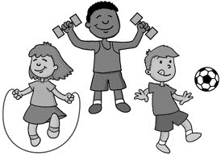

MISOKNG

2. SMOKING

**Direction**: Look at the pictures below. Arrange the jumbled letters to name the different lifestyles that affect the respiratory and circulatory systems.

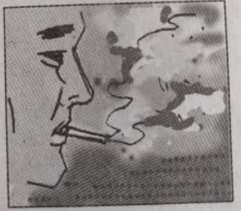***Warning****: Some activities depicted in the pictures below are harmful to your bodies, please do not do or perform such activities.*

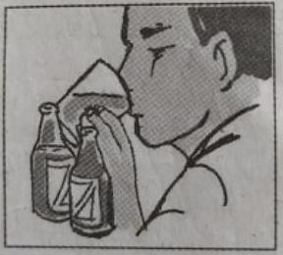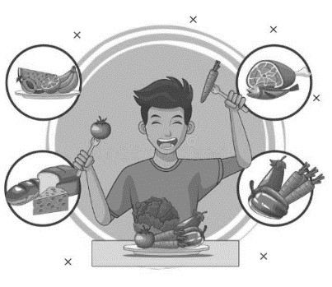

LOHACOL NRIKINDG

1. ALCOHOL DRINKING

LBNAACED EITD

3. BALANCED DIET

XEERCIES

4. EXERCISE

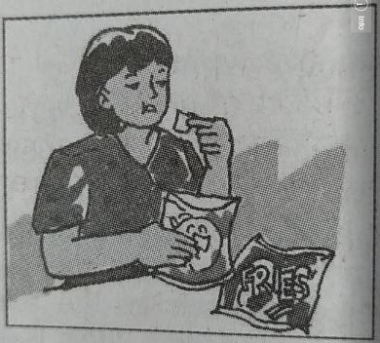

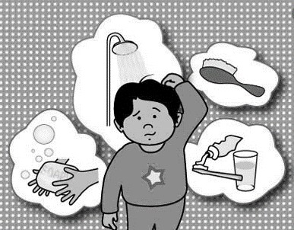

HNEUALTHY IETD

5. UNHEALTHY DIET

RPOPER YHIGENE

6. PROPER HYGIENE

## Activity Number 2- What’s the effect?

**Direction**: Based on activity number 1, write down the effect/s of each lifestyle to our bodies.

|  |  |
| --- | --- |
| ***HEALTHY LIFESTYLE*** | ***EFFECT/S*** |
| 1. Balanced Diet | A balanced diet is a good habit to implement in your daily life and have many health benefits. |
| 1. Exercise | Exercise in morning or anytime of day will help blood circulation and energizes our body. It\s also beneficial to maintain focus. |
| 1. Proper Hygiene | Hot water in evening will help us sleep better because it releases some hormones and cold water in morning will help us being alert and energizes while it improves blood circulation. |
| ***UNHEALTHY LIFESTYLE*** | ***EFFECT/S*** |
| 1. Alcohol Drinking | Affects our nervous system and causes various diseases. |
| 1. Smoking | Particularly affects our respiratory system and leads to stroke and other various diseases. |
| 1. Unhealthy diet | Affects our digestive system. If too much, it can also lead to other problems and complications. |

## Activity Number 3- What’s the result?

Interview or ask your family members/ friends about the different activities that they do that may affect the circulatory and respiratory system. List down the activities and what do you think is/ are the effect/s of it to their bodies.

Example:

Activity: *Gadget addiction/ computer addiction*

This activity results to not having enough rest, feeling tired and loss of appetite.

1. Activity:Drinking Alcoholic Beverages

The activity results to beiong drunk and angriness. Affects his health as well.

1. Activity: Smoking

Relieve stress but causes health to fail/weak immune system and causes time delay to accomplish activities.

1. Activity: Exercising

Helps our physical and mental health to stay healthy and brings more focus to activities.

**Activity No. 5 *– Match, Match, Match!***

*Describing the causes, symptoms, preventions, and treatment of the respiratory diseases.* **Direction:** Match the ailments of the respiratory system in **Column A** with its description in **Column B**. Write your answer on the blanks.

# A B

* 1. Caused by virus characterized by sneezing and runny nose

I 1. Lung cancer

F 2. Pneumonia

G 3. Tuberculosis

A 4. Cold

B 5. Sinusitis

H 6. Throat infection

J 7. Emphysema

C 8. Tonsillitis

E 9. Influenza or flu

D 10. Asthma

* 1. Infection of sinuses due to colds
  2. Swelling of the tonsils that is sometimes accompanied by fever
  3. Respiratory disorder caused of temporary narrowing of the bronchi characterized by difficulty of breathing
  4. An infectious disease of respiratory tract caused by the influenza virus
  5. Inflammation of the lungs caused by wide variety of viruses, bacteria and fungi or may occur also with the inhalation of various dusts and gases
  6. Acute or chronic infectious respiratory disease caused by bacteria Tubercle Bacilli
  7. Also called strep throat caused by streptococcus

i. Disorderly growth of cells in the lungs characterized by chronic cough, blood in the mucus, chest pains, loss of weight and poor appetite

j. Serious disease of the walls of the air sacs

## Activity 5- Protect my lungs and heart

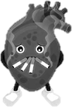

1. **Direction:** Imagine that the pictures below are the lungs and heart of a smoker person, if they could talk what do you think are the pieces of advice they will say to the person to convince him/her to stop with his/her vices?

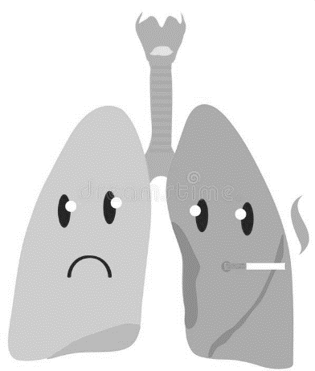

Stop smoking please, if you keep doing it, my part will

not function and you can die in the process while

smoking. It can also affect other parts.

Please stop it, your blood circulation will be affected so badly that you can die. I am pumping blood to supply your whole body.

# Activity 6: Stay safe, stay protected!

Instructions: Read the following article the answer the following guide questions. Article: Coronavirus disease (COVID-19) advice to the public ((WHO) 2020)

You can reduce your chances of being infected or spreading COVID-19 by taking some simple precautions:

* + Regularly and thoroughly clean your hands with an alcohol-based hand rub or wash them with soap and water. Why? Washing your hands with soap and water or using alcohol-based hand rub kills viruses that may be on your hands.
  + Maintain at least 1 meters (3 feet) distance between yourself and others. Why? When someone coughs, sneezes, or speaks they spray small liquid droplets from their nose or mouth which may contain virus. If you are too close, you can breathe in the droplets, including the COVID-19 virus if the person has the disease.
  + Avoid going to crowded places. Why? Where people come together in crowds, you are more likely to come into close contact with someone that has COVID-19 and it is more difficult to maintain physical distance of 1 metre (3 feet).
  + Avoid touching eyes, nose, and mouth. Why? Hands touch many surfaces and can pick up viruses. Once contaminated, hands can transfer the virus to your eyes, nose, or mouth. From there, the virus can enter your body and infect you.
  + Make sure you, and the people around you, follow good respiratory hygiene. This means covering your mouth and nose with your bent elbow or tissue when you cough or sneeze. Then dispose of the used tissue immediately and wash your hands. Why? Droplets spread virus. By following good respiratory hygiene, you protect the people around you from viruses such as cold, flu and COVID-19.
  + Stay home and self-isolate even with minor symptoms such as cough, headache, mild fever, until you recover. Have someone bring you supplies. If you need to leave your house, wear a mask to avoid infecting others. Why? Avoiding contact with others will protect them from possible COVID-19 and other viruses.
  + If you have a fever, cough and difficulty breathing, seek medical attention, but call by telephone in advance if possible and follow the directions of your local health authority. Why? National and local authorities will have the most up to date information on the situation in your area. Calling in advance will allow your health care provider to quickly direct you to the right health facility. This will also protect you and help prevent spread of viruses and other infections.
  + Keep up to date on the latest information from trusted sources, such as WHO or your local and national health authorities. Why? Local and national authorities are best placed to advise on what people in your area should be doing to protect themselves.

Guide Questions:

Q1 When wearing masks, why is it important to make sure that the nostrils and the mouth is covered well?

Because, our nostrils cannot filter virus and other bad bacterias that might affect our whole body. Therefore, we must cover our nose and mouth is covered.

Q2 In your own words, define the term *social distancing*

Social distancing in my opinion is staying away from other people atleast to avoid various diseases that spread out.

Q3 What does the term *respiratory hygiene* mean?

It means protecting and taking care of our respiratory system by avoiding activities or substances that can hurt our respiratory and our whole body.

## Key to Answers Activity Number 1

1. ALCOHOL DRINKING
2. SMOKING
3. BALANCED DIET
4. EXERCISE
5. UNHEALTHY DIET
6. PROPER HYGIENE

## Activity Number 2

*Possible Answers/Answers may vary*

|  |  |
| --- | --- |
| ***HEALTHY LIFESTYLE*** | ***EFFECT/S*** |
| ***1.Balanced diet*** | *May protect the body from different noncommunicable diseases such as obesity, diabetes, cardiovascular diseases, some types of cancer and skeletal conditions* |
| ***2. Exercise*** | *Exercise may improve your muscle strength and boost your endurance* |
| ***3. Proper Hygiene*** | *Proper hygiene protect us from getting*  *diseases that are caused by bacteria and viruses, it helps to wash away those.* |
| ***UNHEALTHY LIFESTYLE*** | ***EFFECT/S*** |
| ***1. Alcohol Drinking*** | *It affects your organs that lead to their damage* |
| ***2. Unhealthy diet*** | *Might lead to overweight/ obesity and too much cholesterol related diseases* |
| ***3. Smoking*** | *Greatly affects your lungs and other organs* |

## Activity Number 4

*Note: Answers may vary depending on the activities the students listed. Sample answer:*

*Activity: Gadget addiction/ computer addiction*

This activity results to not having enough rest, feeling tired and loss of appetite.

# Activity 5

1. I 6. H
2. F 7. J
3. G 8. C
4. A 9. E

5. B 10. D

# REFERENCES

Ornish, Dean, Shirley E. Brown, Larry W. Sherwitz, James H. Billings, WilliamT. Armstrong, Thomas A. Ports, Sandra A. McLanahan, Richard L. Kirkeeidi, Richard J. Brand and Lance K. Gould. 1990. “Can lifestyle changes reverse coronary heart disease? The Lancet, July 21: 129

Rabago, L., eta al, (2010). Functional Biology – Modular Approach 2nd ed. Philippines Vibal Publishing House, Inc.

Gallego and Abelede. (2008) “Workbook in Science”

ScienceLinks Work text for Scientific and Technological Literary

[https://www.euro.who.int/en/health-topics/disease-prevention/nutrition/a-healthy-](https://www.euro.who.int/en/health-topics/disease-prevention/nutrition/a-healthy-lifestyle/benefits-of-a-balanced-diet) [lifestyle/benefits-of-a-balanced-diet](https://www.euro.who.int/en/health-topics/disease-prevention/nutrition/a-healthy-lifestyle/benefits-of-a-balanced-diet)

# Clipart/ Picture References:

Clipart libray, hygiene, Accessed August 13, 2020. <http://clipart-library.com/hygiene-cliparts.html> Dreamstime, Balanced diet, Accessed August 13, 2020. <https://www.dreamstime.com/illustration/balanced-diet.html>

Clipart Library, Exercise, Accessed August 13, 2020. <http://clipart-library.com/exercise-clip-art.html> Dreamstime, Lungs, Accessed August 13, 2020. https://[www.dreamstime.com/illustration/lungs-](http://www.dreamstime.com/illustration/lungs-) smoking.html

Shutter stock, Tobacco, Accessed August 13, 2020. https://[www.shutterstock.com/search/tobacco+cartoon](http://www.shutterstock.com/search/tobacco%2Bcartoon)